Reading Material (646 words):

France and China are working on bionic “terminator” troops

01/03/2021 / By Cassie B.

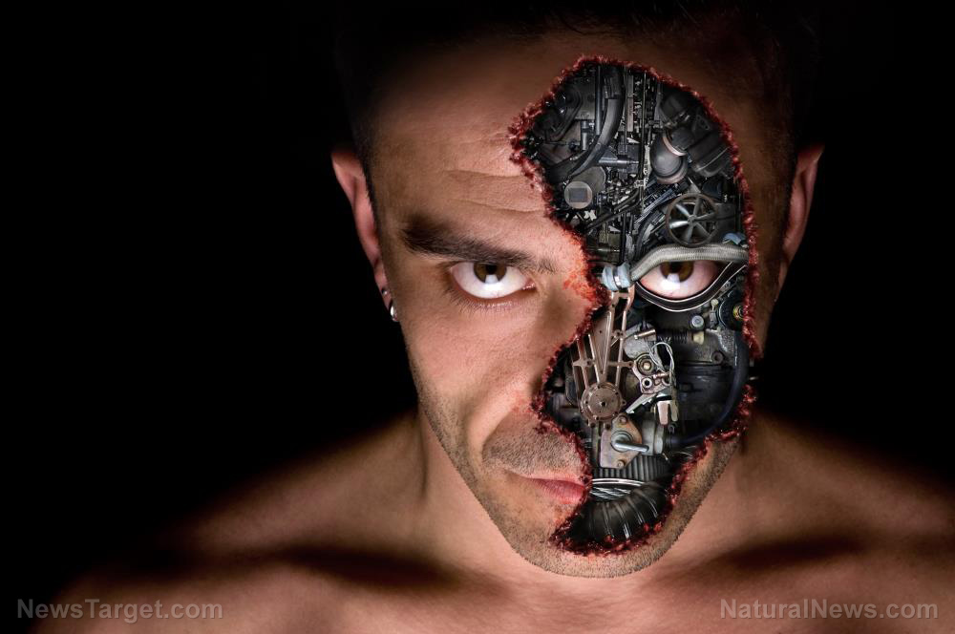
It may not be long before the world has to contend with armies of Terminator troops. We already know that China is developing biologically enhanced “super soldiers,” and now the French military has been given the go-ahead to create so-called “augmented soldiers” by the armed forces ministry’s ethical committee.
France said it is seeking to enhance the cognitive, perceptive, psychological and physical capabilities of its troops through medical treatments to prevent stress and pain, substances to improve mental resilience if a soldier is taken prisoner, implants and prosthetics. The ministry has been researching drugs that can help troops stay awake for long periods of time and fight stress. They are also exploring surgery that can give them sharper hearing.
They are also interested in giving soldiers the ability to connect to other soldiers or weapon systems. They noted that other countries have already been working on advancements of this type, and France is taking these steps to keep up with the competition.
However, they are drawing the line somewhere, with the ethics committee’s report forbidding the use of modifications or implants that might “affect their sense of humanity” or their ability to manage the use of force. They have also banned modifications like cognitive implants that would prevent soldiers from exercising free will and any changes that might impact their reintegration into civilian life.
Although France claims that it plans to follow humanitarian laws, armed forces minister Florence Parly cautioned that not every country is willing to operate ethically, and it is important to be prepared for such realities.

Terrifying developments in the works
Military technology has advanced to frightening new heights in recent years, with sci-fi developments like invisible artificial skin, advanced brain implants and goggles that display combat information just a few of the technologies being developed.
France has reportedly been given the green light to create microchips that can enhance soldiers’ brain power. Hong Kong is developing technology for soldiers’ eyes that could give them night and infrared vision, while the U.S. Army is reportedly testing an exoskeleton that can be attached to soldiers’ legs to give their productivity a 27-fold boost. Red blood cells known as respirocytes are also being explored that could prevent soldiers from getting out of breath and allow them to remain underwater for several hours.
U.S. Director of National Intelligence John Ratcliffe expressed concerns about China’s threat to the U.S. and its plans for military technological advancements in an opinion column for the Wall Street Journal recently, writing: “U.S. intelligence shows that China has even conducted human testing on members of the People’s Liberation Army in hope of developing soldiers with biologically enhanced capabilities.”
He added: “There are no ethical boundaries to Beijing’s pursuit of power.”
King’s College London Visiting Professor in War Studies Michael Clarke said that this race is being spurred by fears of China’s program, telling The Sun: “We’ve reached the point now where we could potentially manipulate people’s DNA to breed into them extra strength, endurance and other things just as we do with animals. Just as we’ve done with standard cattle to give them more back, we can do that now very precisely with humans.”
DNA manipulation could, at least in theory, make the soldiers of the future immune to feelings and diseases. A report by the International Society for Military Ethics in Europe described bionic soldiers who can fight all the time, dubbing them “homo robocopus.”
The report stated: “Enhanced soldiers would be reduced to bionic men, who run fast, do not need sleep, eat and drink very little, and can fight all the time.”
It’s a very scary idea, not only in the context of war. What happens if a group of these terminator soldiers decide to take over the world and the rest of us mere mortals cannot defend ourselves?

Words and expressions:
- contend with： 与 ... 作斗争； 和 ... 争夺
- go-ahead：许可，批准
- augmented：增强的
- mental resilience：心理韧性
- prosthetics：弥补术；修复术
- caution：v. 警告；劝告
- exoskeleton ['eksoʊskelɪtn]：外骨骼；皮骨骼
- respirocyte：呼吸细胞
- dub：把...叫做
- homo robocopus：人机结合体
- be reduced：使变成
- bionic：仿生学的

Comprehension questions:
1. How does France seek to enhance the cognitive, perceptive, psychological and physical capabilities of its troops?
2. What is biased attitude the report takes to China’s development of soldiers with biologically enhanced capabilities?
3. What is potential risk in developing bionic men?

